The Well  ‘The Well’ draws its concept from the African and Asian countries where a ‘well’ plays a crucial role in not only providing water but also a means of socialising, gathering and sharing own stories or experiences with others, thus creating friendships, a sense of wellness and togetherness.  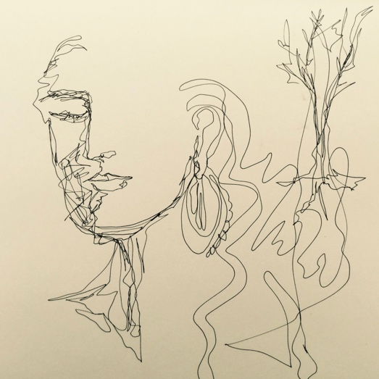  Inviting all women in Sunderland & South Tyneside  Learn, share, build confidence, make friends through art, crafts and well -being activities, such as yoga and meditation, healthy eating advice and organize drop-in sessions.  Over the past years we found that more and more women are being isolated due to many reasons, some unforeseen circumstances, caring responsibilities, migration or loss of employment. This project aims to bring women together and help build a sense of community among them. We just want to say – you are not alone!  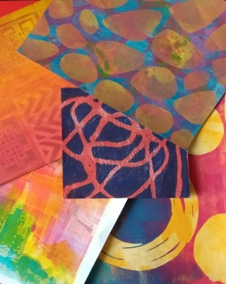  Art classes currently taking place every Friday, 10.30 am – 12.30 pm at CHANCE, 2, Rickaby Street, East End, Sunderland SR1 2DL  For more information, contact Nina Sumby on 07837639081 or 07885982436 or email: projectsangini@gmail.com  https://sanginiafriend.wordpress.com  https://www.sangini.co.uk | We are a women-led, multi-cultural women’s organisation with a focus to encourage women from different communities to engage in educational, creative and participatory activities by providing support and encouragement, thereby removing social and cultural barriers they may face in their everyday lives.  This project is funded by Foyle Foundation, Big Lottery and COUNTY DURHAM COMMUNITY FOUNDATION from the Tampon Tax Community Fund
